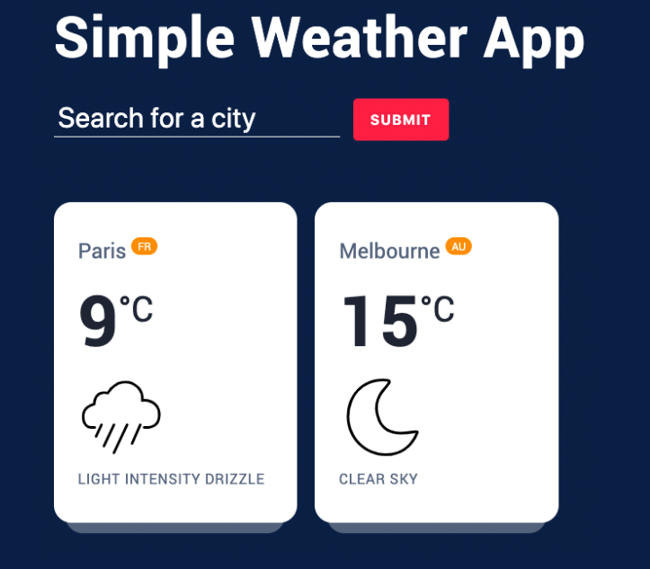

You have to create a simple weather application like above, it would be great if you could follow styles as well

**Requirements:**

There are multiple free to use 3rd party application user interfaces available over the internet which you can use to fetch the weather details for a city. So you have to implement an ajax call to this application user interface (API) for this and display the weather details of searched city. If user haven’t searched any city, so you can display 5 famous cities weather details and change after 5 second to another city. This should be going infinitely until user search for any city. If user clears the search field, same functionality should continue which was previously working.

**Deliverables:** Code should be clean and understandable; you can use comments where you think it’s necessary. You have to push all the files to git in public repo and share the URL. **Best of Luck!**!